Extraordinary Leadership
February 14, 2015
There are probably quite a few average leaders – but there are some simple competencies hat can take average to extraordinary. Getting caught up in the day-to-day can take us away from the leadership actions we need to practice, so use these six actions to become an extraordinary leader.
Focus on the big picture. Some leaders have to wear the hat of manager and leader.
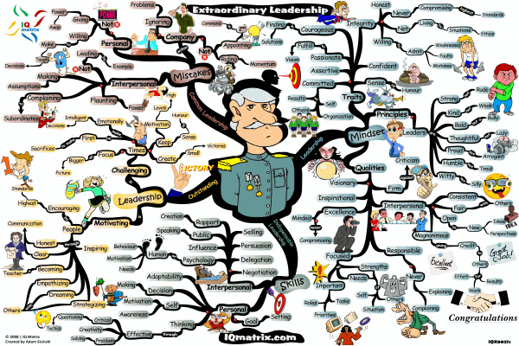
Some of us don’t but still find it easy to dive into the details. If you’ve taken the time to create a top team around you, keep your focus on your big picture and vision. When you do this, the organization will know that someone is always focused on the big picture – and where the organization is in relation to it. Let your team handle the smaller details – and stay focused on the big picture.
Don’t get caught in the day-to-day squabble. Organizations consistently go through forming, storming, and norming phases – whenever a team has a turnover it’s easy to start that whole process again. When teams get to the storming phase, they will probably begin to “squabble” amongst themselves over important, and not so important issues. When this happens, you must have faith that the team can work it out on its own. The temptation is to play sage leader and solve the minor infighting problems that occur and we must avoid that impulse. If a team member comes to you with a problem, offer advice but don’t offer to get involved. As leaders, we must be involved at the right times – and know when it’s the wrong time.
Be the first to act. When things get tough, the leader should be the first one to acknowledge the fact. If it’s a financial issue, be the first one to take a cut. But on the other hand, our teams sometimes forget to acknowledge success or progress. If this is the case, be the first one to acknowledge a success – even a small one. When it comes to innovation, don’t sit on an idea simply because it’s risky – examine it and move forward if it can do the same for your organization. Leadership is all about being the first one to make a move. Sometimes what separates the leaders from the rest of the crowd is their ability to step out on a limb – and lead.
Be a motivator. Somehow leaders get motivation mixed up with telling the organization what they’re doing wrong. Although that’s part of it, remember that motivation can come at any time, especially when there’s been a failure or a lack of progress. Dwight Eisenhower once said, “leadership is the art of getting someone else to do something you want done because he wants to do it”. To motivate your organization you must show the benefits of every action – and this means you have to know your teams and what they do. When people feel that they are spinning their wheels, know how to redirect them through motivation – explain how what they are doing is helping the organization reach its goals and vision. It’s been said that motivating people may be one of the hardest skills to master. But if you can show people why they’re doing what they’re doing, you’ll be a step ahead in the motivation arena.
Keep it real. We’ve all heard this expression, but for a leader it’s imperative. Keeping it real means that you have to acknowledge that life goes on outside of your organization. It’s the admission that if it all folded up in one day, you would go home to your family, pick up the pieces, and start over again. It also means that you have to keep a sense of humor – and show it to the organization. Part of getting people to follow you is showing them that you are just as human as they are – and keeping it real is a good way to do it. Don’t take yourself too seriously, either. If the joke’s on you, admit it. If you’ve made a mistake, admit it. The humanity and humility of leadership is something that will keep your organization behind you.
Value and leverage diversity. The diversity of your organization will help you keep it real. You’ve got to look for all kinds of people, with all kinds of skills, to move your organization forward and keep it competitive. The diversity of your organization also helps you keep that humanity and humility in your leadership style. But think about diversity a little further than what’s on the outside: an organization made up of people from diverse backgrounds will keep the ideas and innovations flowing. In a diverse organization, people think differently from each other – instead of all the same. In this way you can leverage diversity and keep the organization moving.
Obviously these six actions have to be tempered with other leadership competencies. But if you remember to focus on the big picture, don’t get caught up in the daily squabble, to be the first to act, be a motivator, keep it real, and value diversity, you’ll be able to change ordinary leadership into extraordinary leadership.
By Evan Dodson

