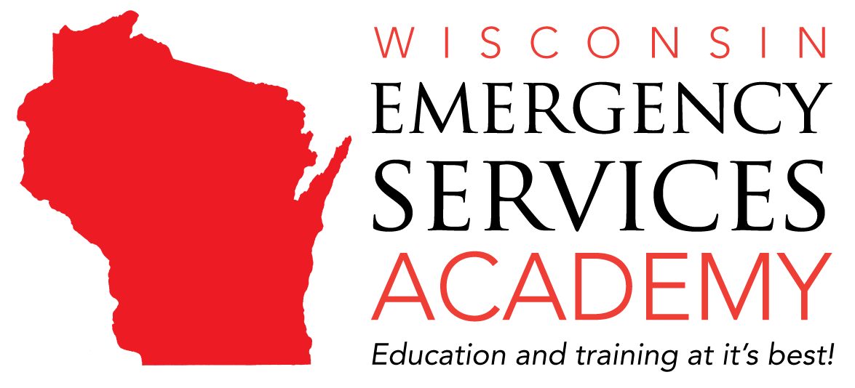
Task Sheet 16
FIRE OFFICER III
JPR: 1021, 2020 EDITION

Candidate: _______________________________________ Module 1, 2 and 3

JPR: 6.5.2

Task: Develop a plan, given an identified fire safety problem, so that the approval for a new program, piece of legislation, form of public education, or fire safety code is facilitated.

Performance Outcome: The candidate will demonstrate the ability to use evaluative methods, to use consensus-building techniques, to communicate orally and in writing, and to organize plans.

Conditions: Given knowledge, training, and experience of department members, the candidate shall

Date Pass/Fail Initials
- Review gathered inspection data to determine trends of code violations or fire safety problems.
- Develop plan that addresses trends and provides recommendations for improvement or elimination of problem chosen. Circle type to be facilitated:
- New program
- Form of Public Education
- Piece of Legislation
- Fire Safety Code
- Present written and verbal documentation for the method used to address the fire safety problem using consensus-building techniques.

Comments: _________________________________________________________________________

___________________________________________________________________________________

___________________________________________________________________________________

_________________________________________________________________________________
Evaluator Date

___________________________________________________________________________________
Re-Test Evaluator Date

______________________________________________________________________________________
UWO Examiner Date

