# Uploading My Poster for CERCA Directions

1. Open the following link in Chrome or Firefox: <https://uws-ce.instructure.com/enroll/AG8XKL>.
2. Click the **UW Employee / Faculty / Student** link.



1. Use your UWEC credentials and login to Canvas.
2. Select the **CERCA: 2021 Virtual Event** course from your dashboard.
3. Select the **CERCA 2021 Presentation** file in the *Navigating CERCA* module.

1. Either download a copy of the file (this way you can sort and/or use the ‘Find’ function) or use the tools on the current screen to zoom in, scroll, and move through the pages of the document.

1. Identify the large category that you are in and your faculty mentor’s department. ***Categories are based on you Faculty Mentor’s Academic Department.***
2. Once you find the category, find your name and faculty mentor’s department. If you are unsure of your large category, you will need to find your name in the spreadsheet.
3. Go back to the home page of the Canvas course. Click on your large category title (based on faculty’s department) in the *CERCA Poster Presentations* Module.
4. Click on your faculty mentor’s department. Graphical user interface

   Description automatically generated
5. Find the title of your presentation and click on it.

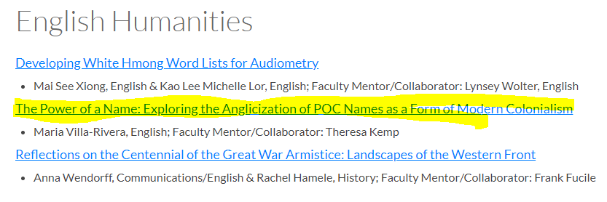

1. Upload your poster by selecting **Reply**. You may also want to subscribe to your discussion. By selecting *Subscribe*, you will receive an email message when someone posts questions or remarks to your poster presentation.

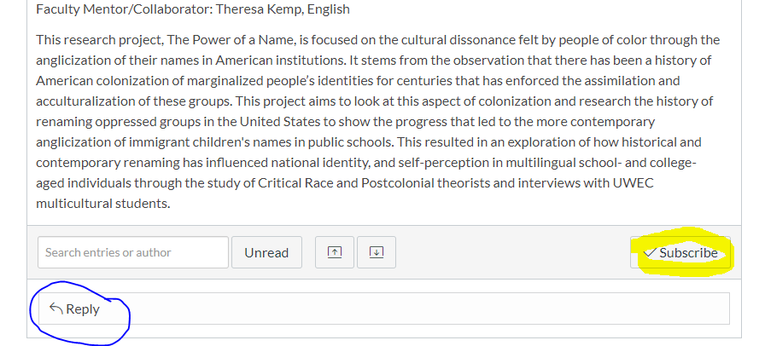

1. If you created only a PowerPoint slide, but did not create a video with a voice over, please save your PowerPoint as a PDF and attach it to the discussion. If you created a voice-over PowerPoint, you can upload it into the Rich Content Editor. If you need assistance creating that voice over, use this [link](https://www.uwec.edu/kb/article/how-to-add-audio-to-powerpoint-on-windows-10-and-mac/) for details. If you are uploading a video, view this [link](https://www.uwec.edu/kb/article/upload-and-embed-a-video-in-canvas-using-the-rich-content-editor/) for details.

**Please note: We are aware that the resolutions of the large individual PP slides with embedded audio files (MP4) are substantially lower than the original PPT or PDF files.  Presenters are welcome to upload presentation twice, once with the voice over and once without the voice over.**

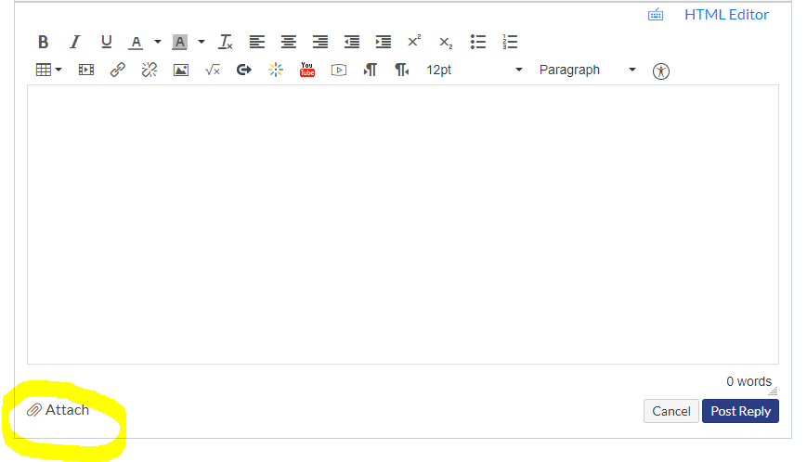

1. Select **Choose File** and navigate to the location where your file is saved to select it. Next, select **Post Reply**.

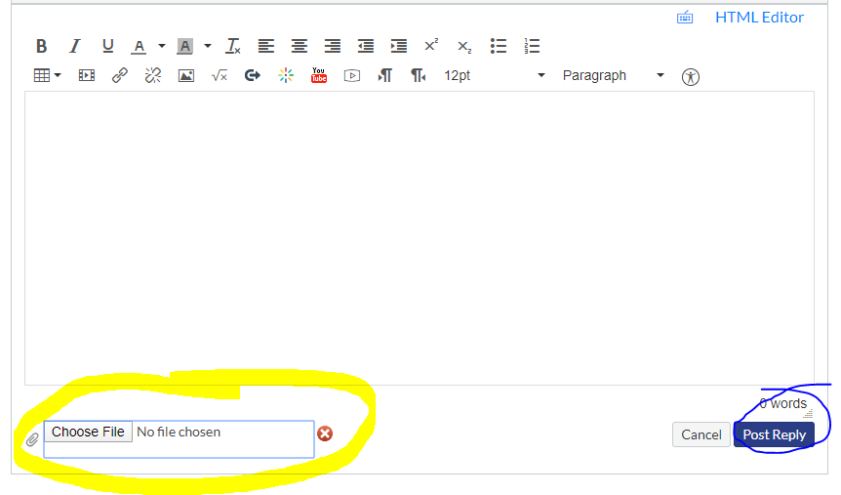

**Congratulations! Your poster presentation is posted and ready for others to view.**